**Java Rice**

**An Interactive Food Ordering System**

@BSCS1A

SY: 2022-2023

About Us:



**Kurt Daniel S. Cano**

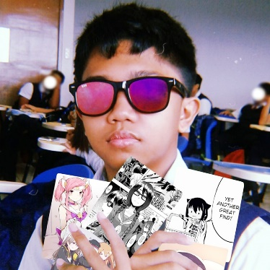

**Mike Rufino J. Caram II**



**Joshua O. Lonoza**



**Kevin A. Llanes**



**Jhon Keneth Ryan B. Namias**

"Now you'll Meat your End." -Vergil

Table of Contents:

Contents

About Us: 1

Table of Contents: 1

I. Introduction: 2

II. Objectives: 2

III. Methodology: 2

IV. Timeline: 2

V. Limitations: 2

VI. Criteria: 2

VII. Conclusion: 2

VIII. References: 3

IX. Appendix: 3

X. Flowchart: 3

XI. Changelog 4

Alpha Build: February 3, 2023 - February 10, 2023 (Week 1 - 2) 4

i. UI and Logo Design: 4

ii. Database: 8

iii. Forms: 10

iv. Functions: 10

v. Color Palette: 10

vi. References for Databases: 10

I. Introduction:

Java Rice is a food ordering system designed to make the process of ordering food easier for users. The system is built using Java and Maven GUI, which provides an interactive and user-friendly experience. The purpose of this system is to allow users to order their favorite meals with ease and convenience.

II. Objectives:

* To provide a platform where users can order food with just a few clicks.
* To make the process of food ordering fast and efficient.
* To provide users with an interactive and user-friendly experience.
* To provide a secure and reliable platform for food ordering.

III. Methodology:

* The system will be built using Java programming language and Maven GUI for the front-end interface.
* A database will be used to store all the information about the food items and orders.
* The system will provide a user-friendly interface for users to place their orders.
* The system will use secure payment methods to process the transactions.

IV. Timeline:

* Planning and Design Phase: 2 weeks
* Development Phase: 4 weeks
* Testing and Debugging Phase: 2 weeks
* Deployment Phase: 1 week

V. Limitations:

* The system will only be available for use on devices with Java and Maven GUI installed.
* The system will only support online payment methods.
* The system will not provide delivery services.

VI. Criteria:

* Usability
* Availability
* Reliability
* Maintainability
* Security

VII. Conclusion:

Java Rice is a food ordering system designed to provide users with a fast and convenient way to order food. The system is built using Java and Maven GUI, which provides an interactive and user-friendly experience. The system will provide a secure platform for food ordering and will be accessible on devices with Java and Maven GUI installed. The estimated timeline is 9 weeks.

VIII. References:

* Java Programming Language Reference: Oracle Corporation
* Maven GUI Reference: Apache Software Foundation
* <https://PP-Namias.Github.io/Java-GUI/>

IX. Appendix:

* Detailed project plan
* Technical specifications
* UI Design
* Database
* Functions
* Color Palette

X. Flowchart:

XI. Changelog

*This is compilation and record of development progress and notable changes made from inside-out and start-to-finish of the program or also known as changelogs.*

Alpha Build: February 3, 2023 - February 10, 2023 (Week 1 - 2)

**Planning and Designing Phase**, this week's development progress will be focused on finding references, brainstorming, and planning for program design, as well as making the most of available time to ensure efficient and progressive coding in subsequent weeks.

The Plan is to make a structure of what program will be created, it includes the design of possible future User Interface of the program that will be used for referencing and on top of that is to brainstorm a plan as well as Logo Designing. Created four initial databases named as: Products, Carts, Order, Sales

i. UI and Logo Design:

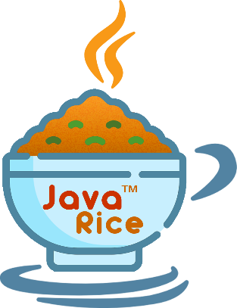

Java Rice Logo [Transparent]



Java Rice Banner with Logo [Transparent]



Java Rice Banner [Transparent]

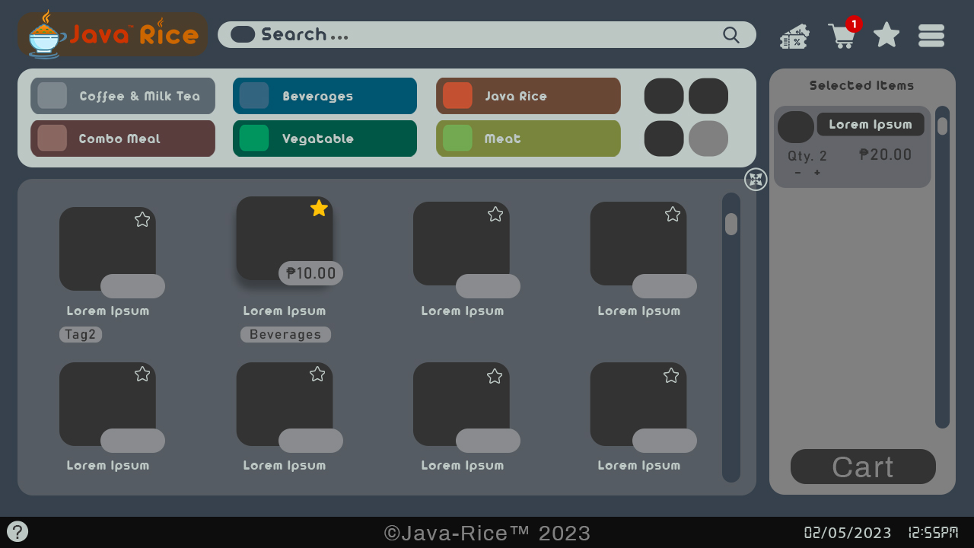

Java Rice Main Form [Regular]

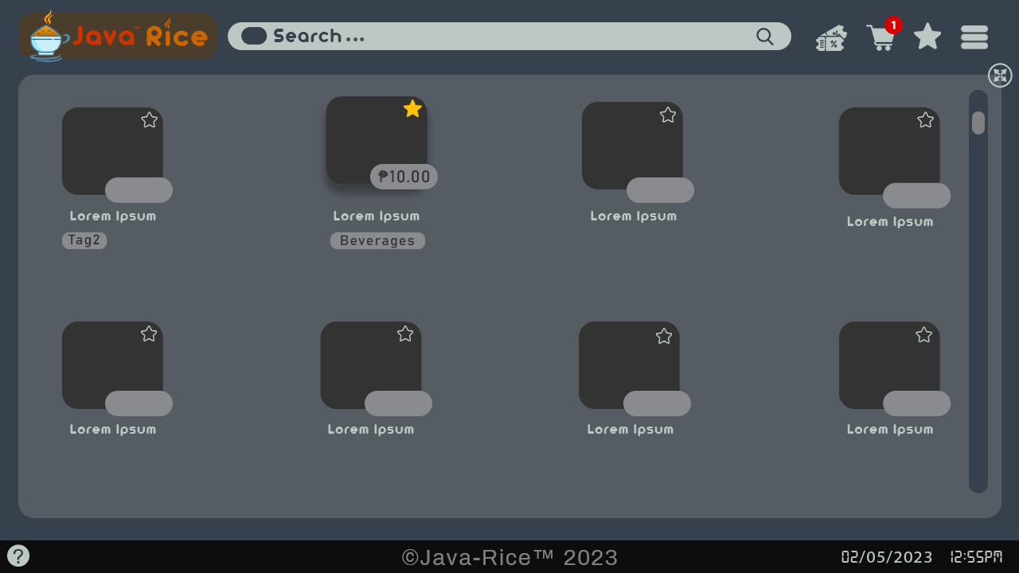

Java Rice Main Form [Maximize]

**

Java Rice Receipt [Default] Java Rice Receipt [Example]

ii. Database:

CREATE TABLE IF NOT EXISTS **Products** (

**Product_ID** SERIAL NOT NULL PRIMARY KEY,

**Name** TEXT NOT NULL,

**Category** TEXT NOT NULL,

**Store_num** TEXT NOT NULL,

**Price** DOUBLE PRECISION NOT NULL,

**Image** OBJ NOT NULL,

**Popular** BOOL NOT NULL

);

CREATE TABLE IF NOT EXISTS **Cart** (

**Product_ID** SERIAL NOT NULL PRIMARY KEY,

**Name** TEXT NOT NULL,

**Category** TEXT NOT NULL,

**Store_num** TEXT NOT NULL,

**Price** DOUBLE PRECISION NOT NULL,

**Image** OBJ NOT NULL,

**Quantity** INT NOT NULL,

**Voucher** TEXT NOT NULL,

**Discount** DOUBLE NOT NULL

);

CREATE TABLE IF NOT EXISTS **Order** (

**Order_ID** SERIAL NOT NULL PRIMARY KEY,

**Product_ID** SERIAL NOT NULL,

**Name** TEXT NOT NULL,

**Category** TEXT NOT NULL,

**Store_num** TEXT NOT NULL,

**Price** DOUBLE PRECISION NOT NULL,

**Image** OBJ NOT NULL,

**Quantity** INT NOT NULL,

**Voucher** TEXT NOT NULL,

**Discount** DOUBLE NOT NULL

);

CREATE TABLE IF NOT EXISTS **Sales** (

**Order_ID** SERIAL NOT NULL PRIMARY KEY,

**Product_ID** SERIAL NOT NULL,

**Category** TEXT NOT NULL,

**Store_num** TEXT NOT NULL,

**Quantity** INT NOT NULL,

**Date_processed** DATE NOT NULL,

**Profit** DOUBLE NOT NULL

);

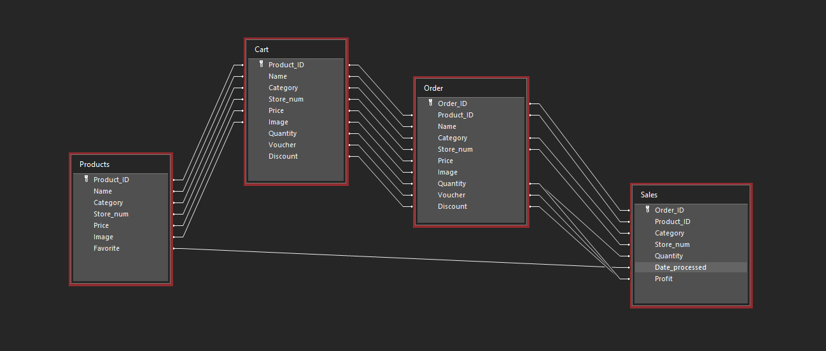

iii. Forms:

* MainForm
* Developer_Settings
* Cashier
* Receipt

iv. Functions:

* Ordering system [multiple selections]
* Auto-generated search bar
* Receipt
* Order logs
* Items order
* Order number
* QR Code [generator] [reader]
* Voucher Discounts

v. Color Palette:

* **Main Background:** #36414d rgb(54, 65, 77)
* **Foreground:** #898b8e rgb(137, 139, 142)
* **Text (Dark):** #36414d // Light Background rgb(54, 65, 77)
* **Text (Light):** #bcc7c4 // Dark Background rgb(188, 199, 196)
* **Other:**
  + #333333 rgb(51, 51, 51)
  + #5182a1 rgb(81, 130, 161)
* **Cart:** #808080
  + #63656a rgb(99, 101, 106)
* **Footer:** #0d0d0d rgb(13, 13, 13)
* **Logo:**
  + #cc3300 // Java rgb(204, 51, 0)
  + #cc6600 // Rice rgb(204, 102, 0)

vi. References for Databases:

**Store: [Name]#_**

**Food Price: ####.##**

**Products: [ProductName]**

**Food Category:**

* + **Beverages** {Cola, Softdrinks, Tea, Coffee, Milk, Energy Drink, Hot Chocolate, Milk Tea (sub categ.?), Water, Juice}
  + **Combo Meal** {Rice + 2 dish, e.g.: Rice + Vegetable + Meat, or any combo}
  + **Vegetables** { Adobong Kang-kong, Pinakbet, Ginataang Kalabasa, Lumpiang Togue, Ginisang Togue, …}
  + **Meat** {Curry, Adobo, Bicol Express, Fried Chicken, …}
  + **Fish** {Paksiw, Fried Fish, Lumpiang Shanghai, …}
  + **Snacks** {Bananacue, Ginataang Bilo-bilo, Turon, …}
  + **Noodles** {Palabok, Pancit Bihon, Spaghetti, Pares, Mami, Lomi, …}
  + **Milk Tea** { }